Discover Goa with INTRO TRAVELS INDIA
Goa, India’s most famous beach destination, is a tropical paradise known for golden beaches, vibrant nightlife, Portuguese heritage, luxury resorts, water sports, delicious seafood, and scenic landscapes. Located on the western coast of India along the Arabian Sea, Goa is the perfect destination for honeymooners, families, solo travelers, adventure lovers, and party enthusiasts.
Whether you want relaxing beach holidays, thrilling adventures, or lively nightlife, Goa offers an unforgettable travel experience.

Why Visit Goa?
- Beautiful beaches & sunsets
- Famous nightlife & beach parties
- Luxury resorts & beach shacks
- Adventure water sports
- Portuguese heritage & architecture
- Delicious seafood & Goan cuisine
- Relaxing tropical atmosphere
- Perfect destination for every traveler

Top Tourist Attractions in Goa
1. North Goa
The most vibrant part of Goa, famous for nightlife, beaches, and entertainment.
Popular beaches:
- Baga Beach
- Calangute Beach
- Candolim Beach
- Anjuna Beach
Best experiences:
- Beach clubs & nightlife
- Water sports
- Shopping markets
- Sunset cafés
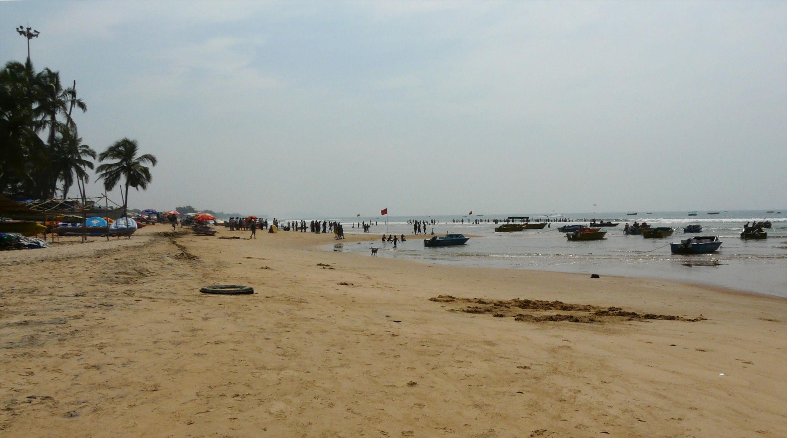
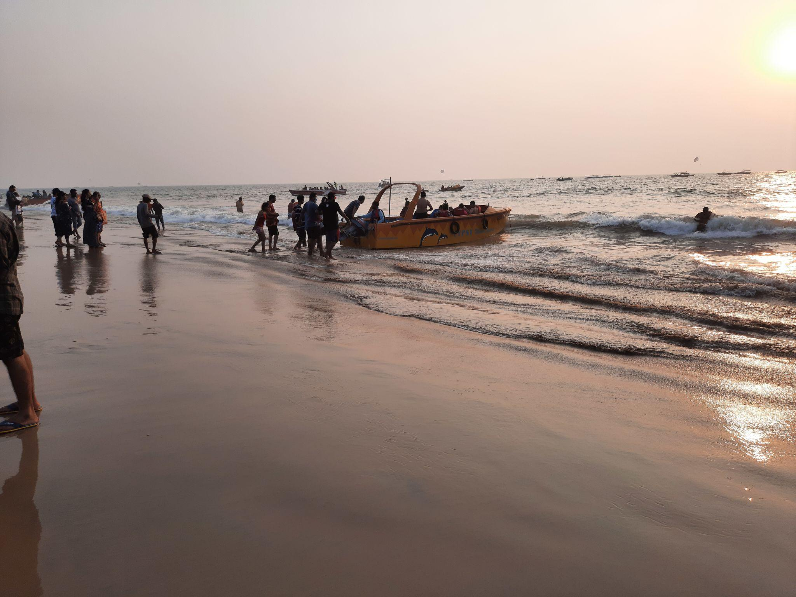
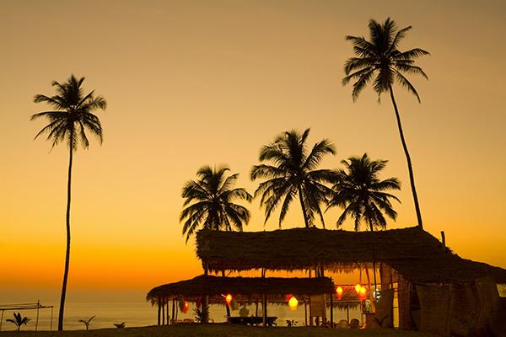
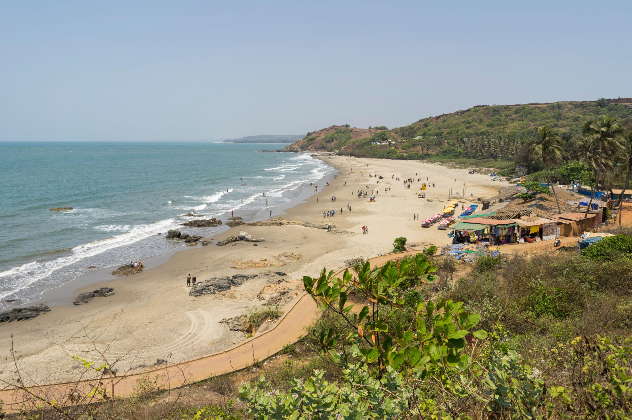

2. South Goa
Known for peaceful beaches, luxury resorts, and relaxing vacations.
Famous beaches:
- Palolem Beach
- Colva Beach
- Agonda Beach
- Benaulim Beach
Perfect for:
- Honeymoon trips
- Luxury stays
- Family holidays
- Peaceful beach relaxation
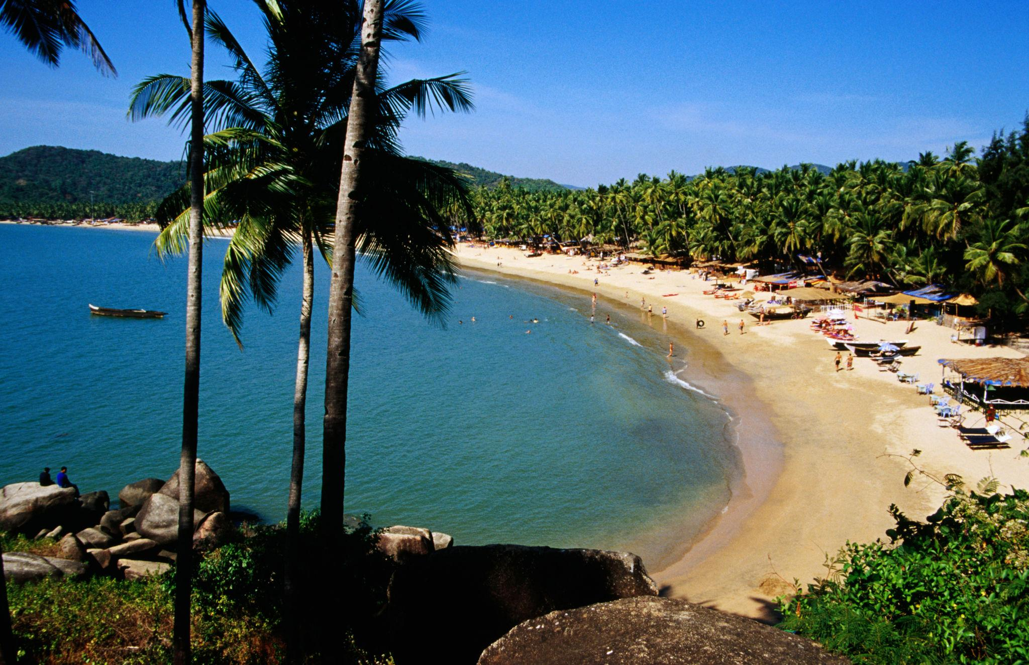
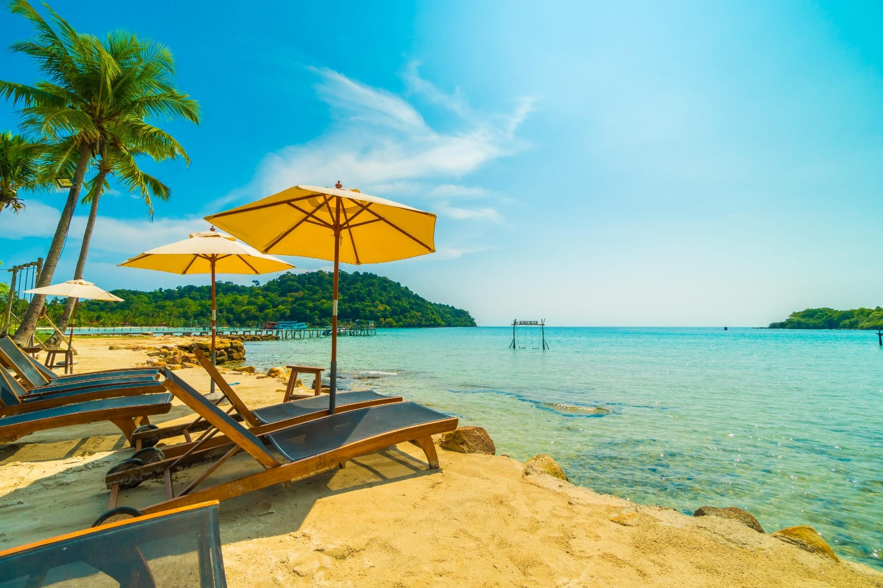
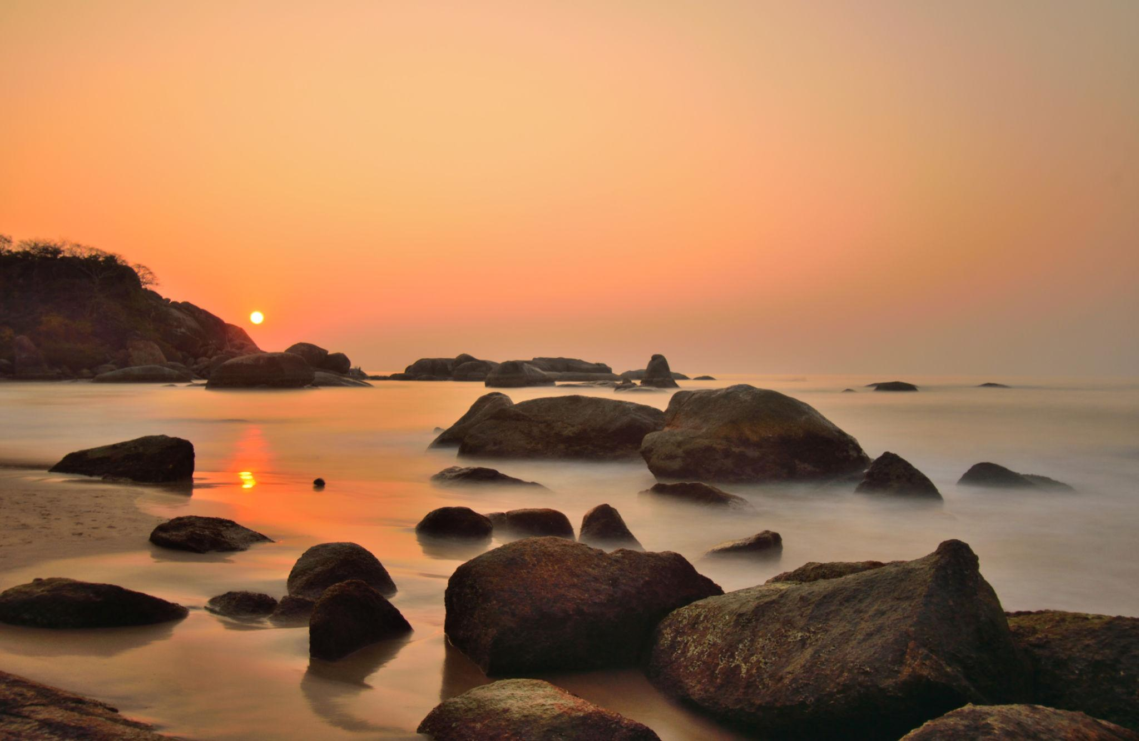
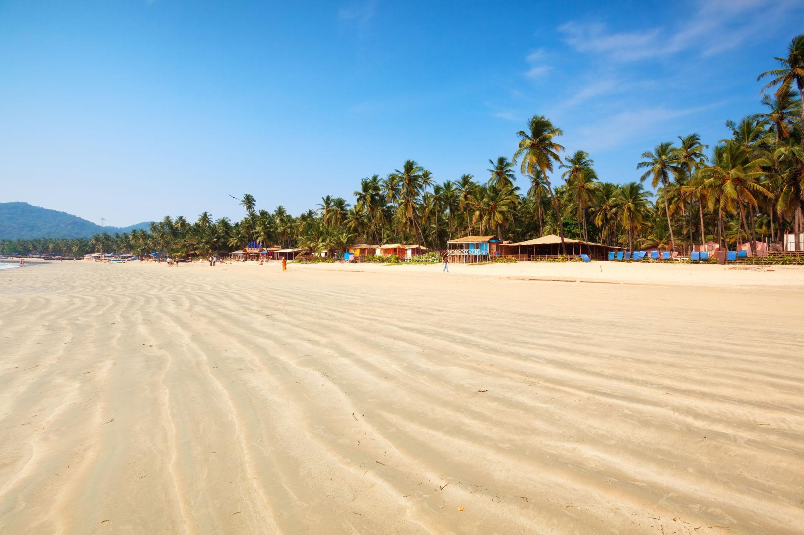
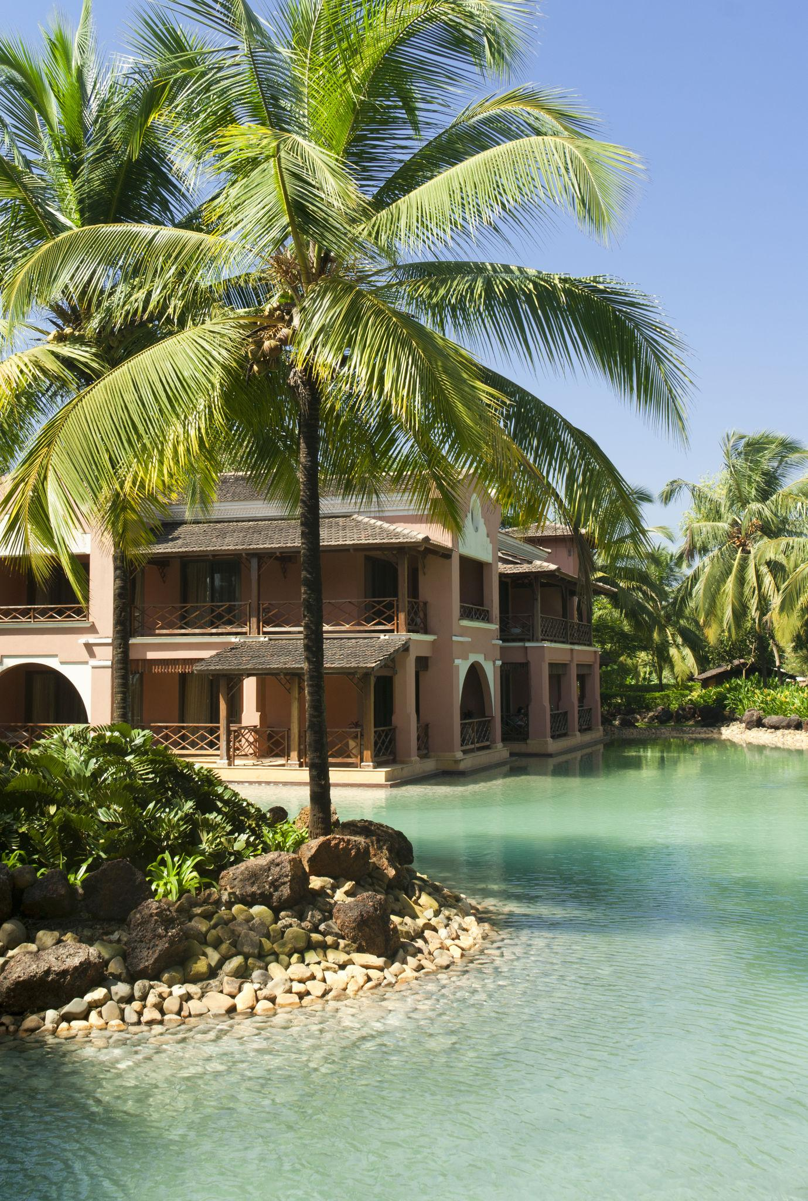
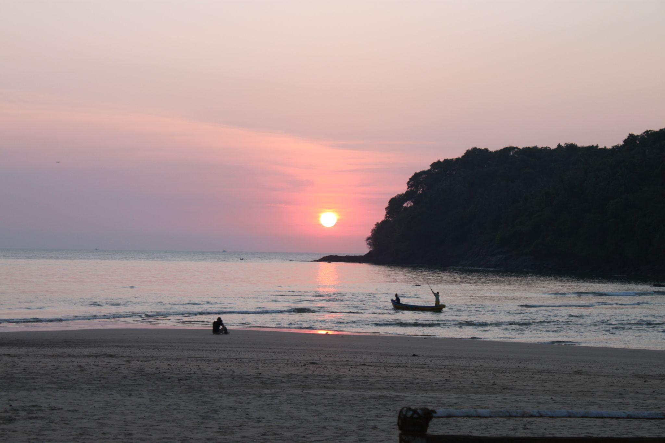

3. Basilica of Bom Jesus
A UNESCO World Heritage Site famous for Portuguese architecture and religious importance.
Highlights:
- Historic church architecture
- Christian heritage
- Beautiful interiors
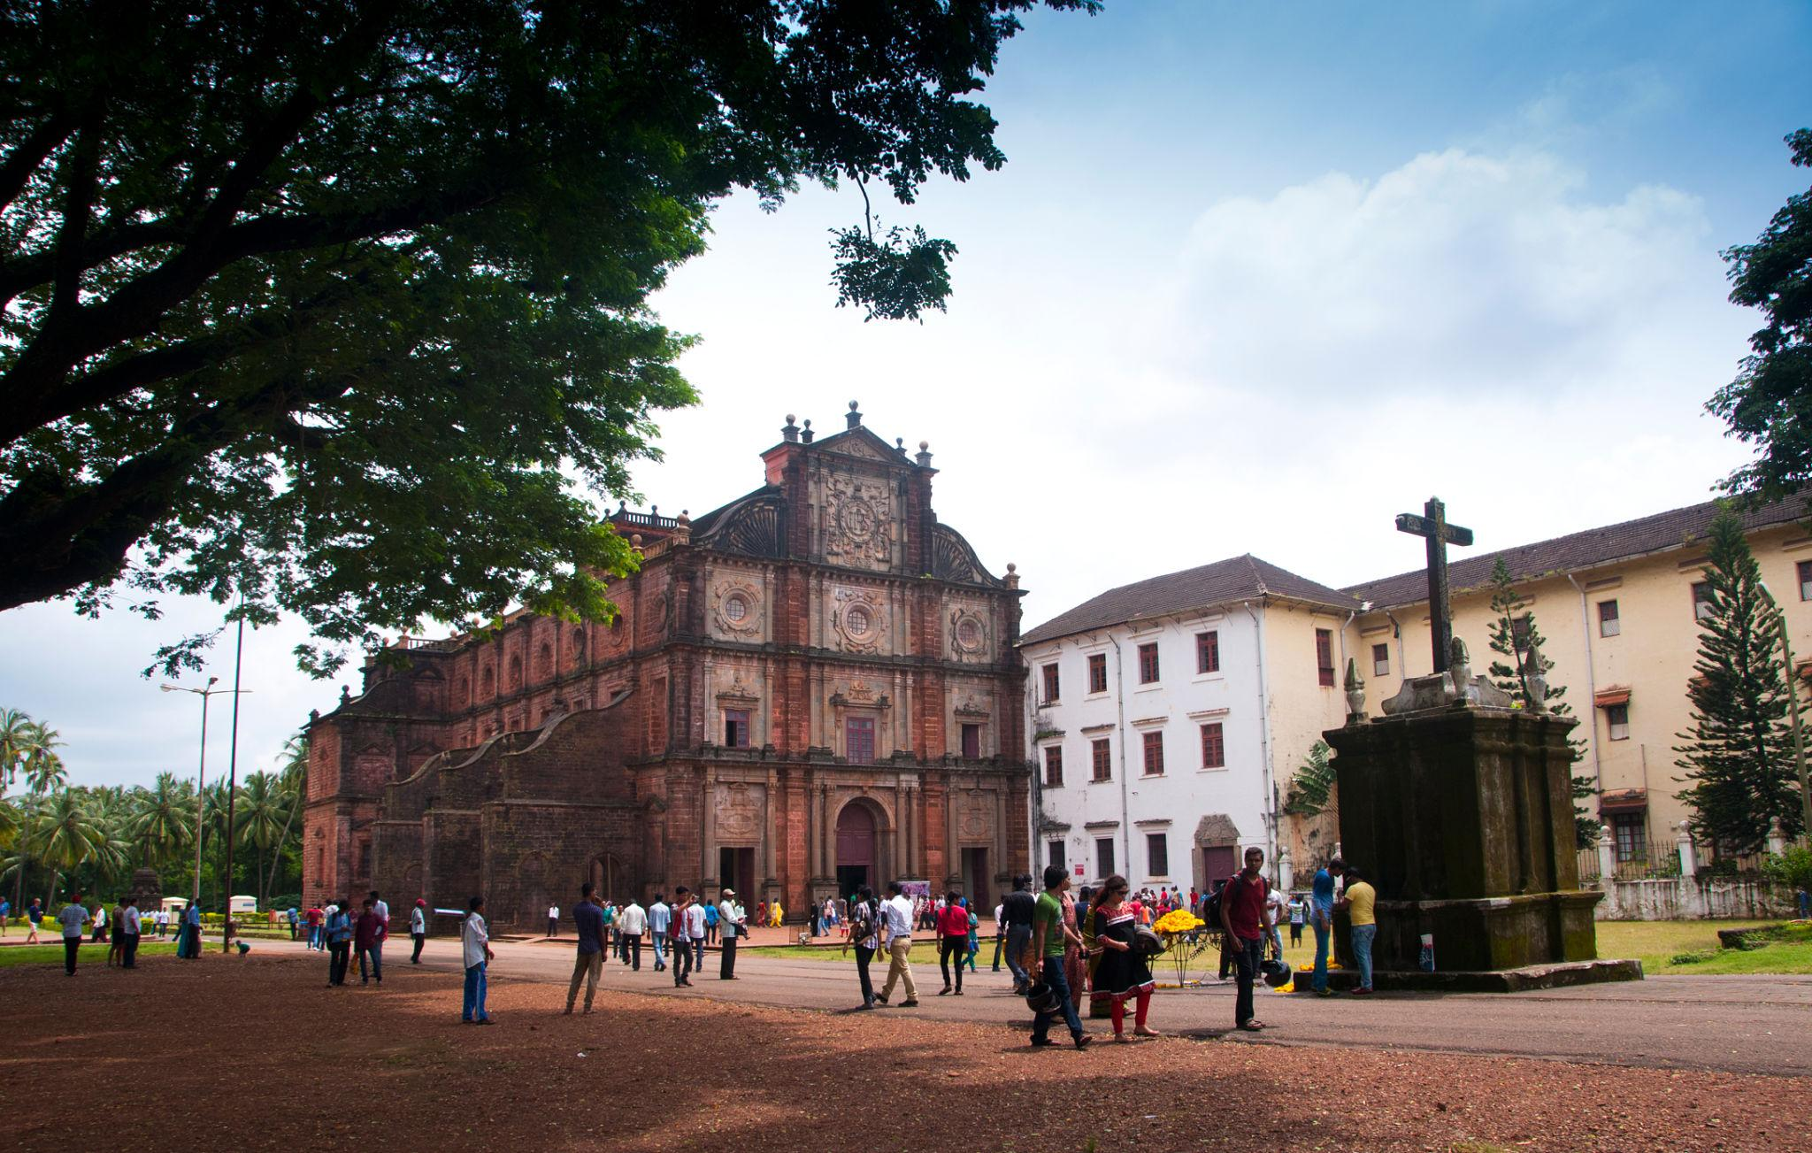
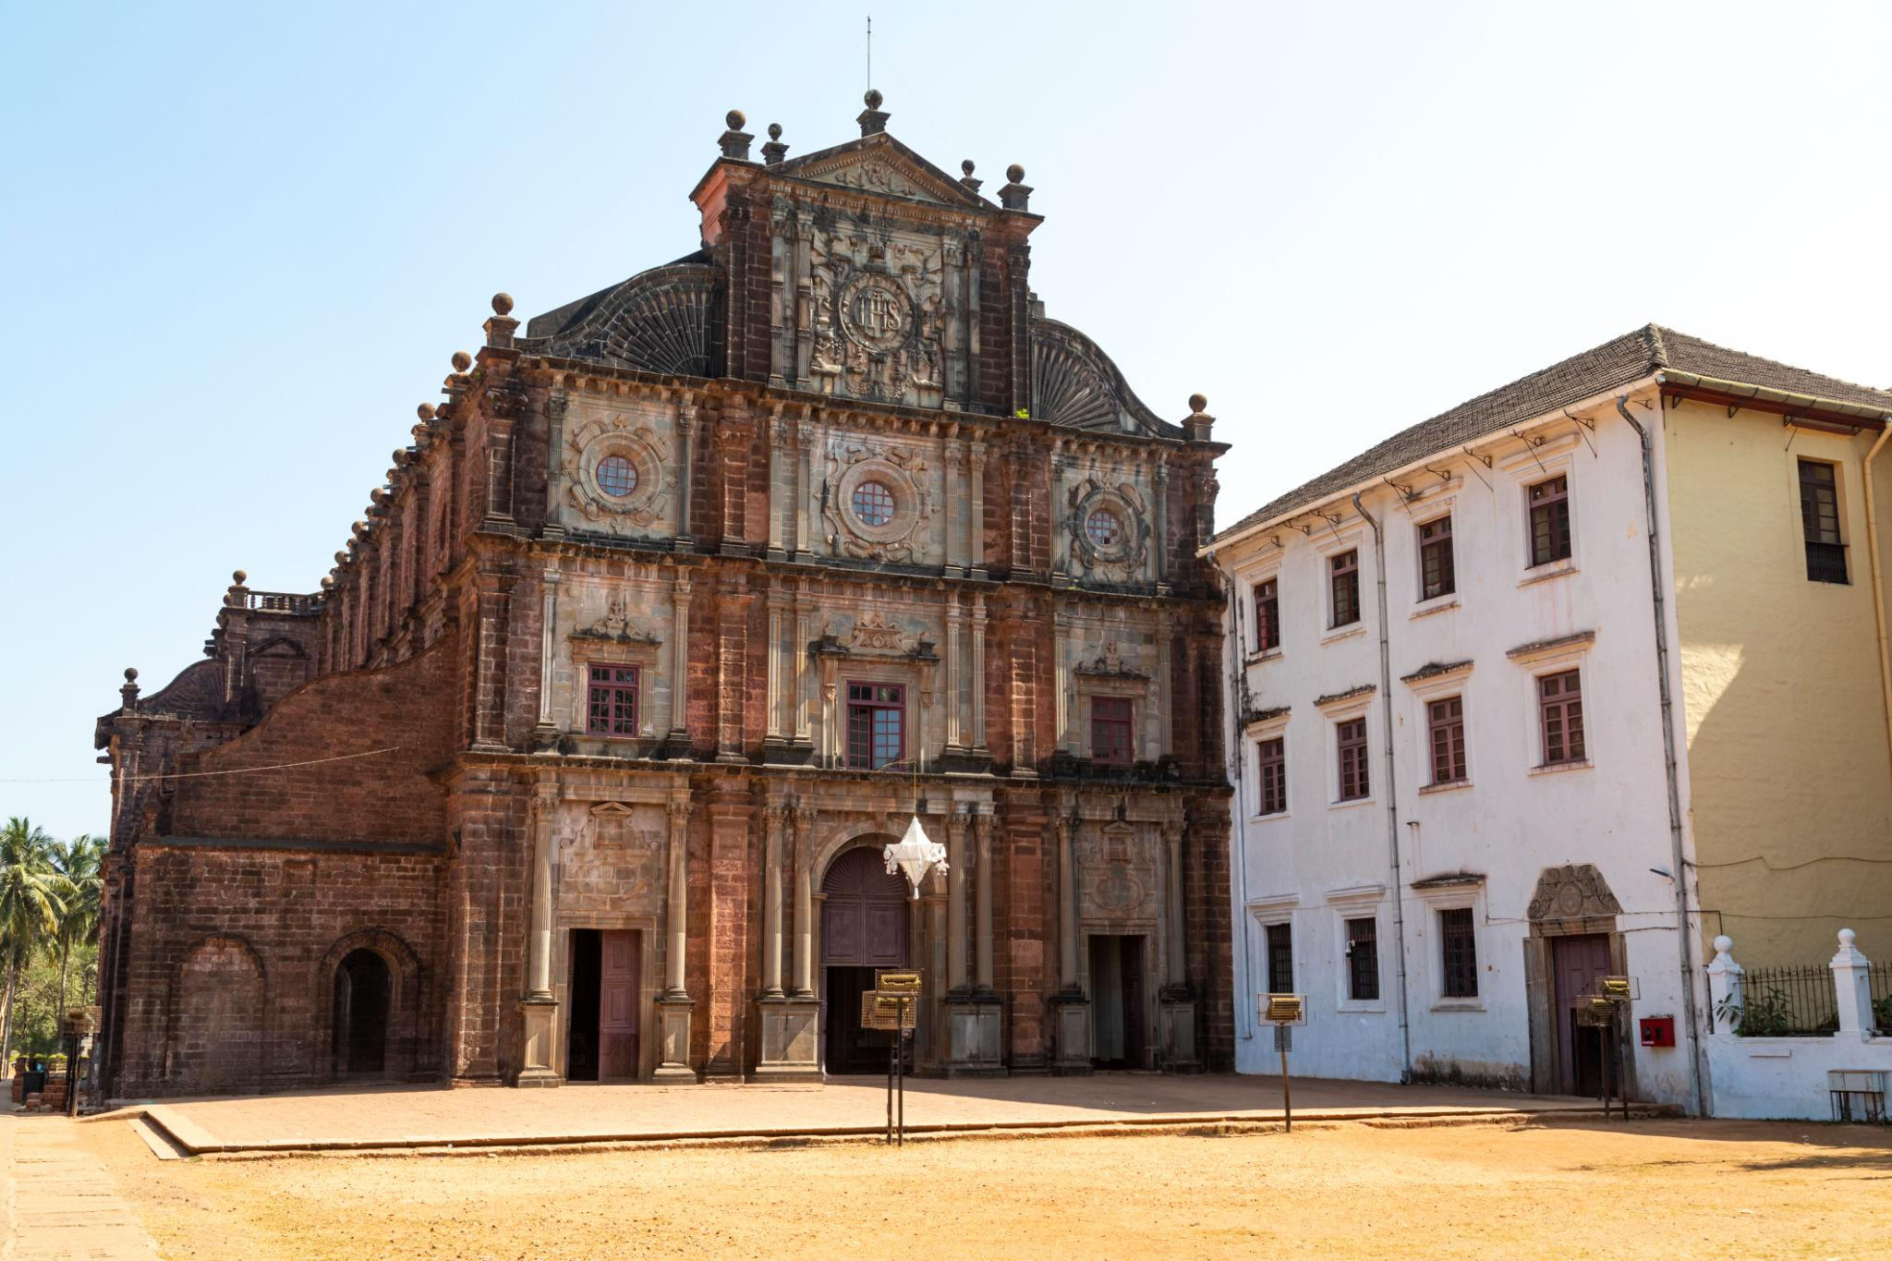
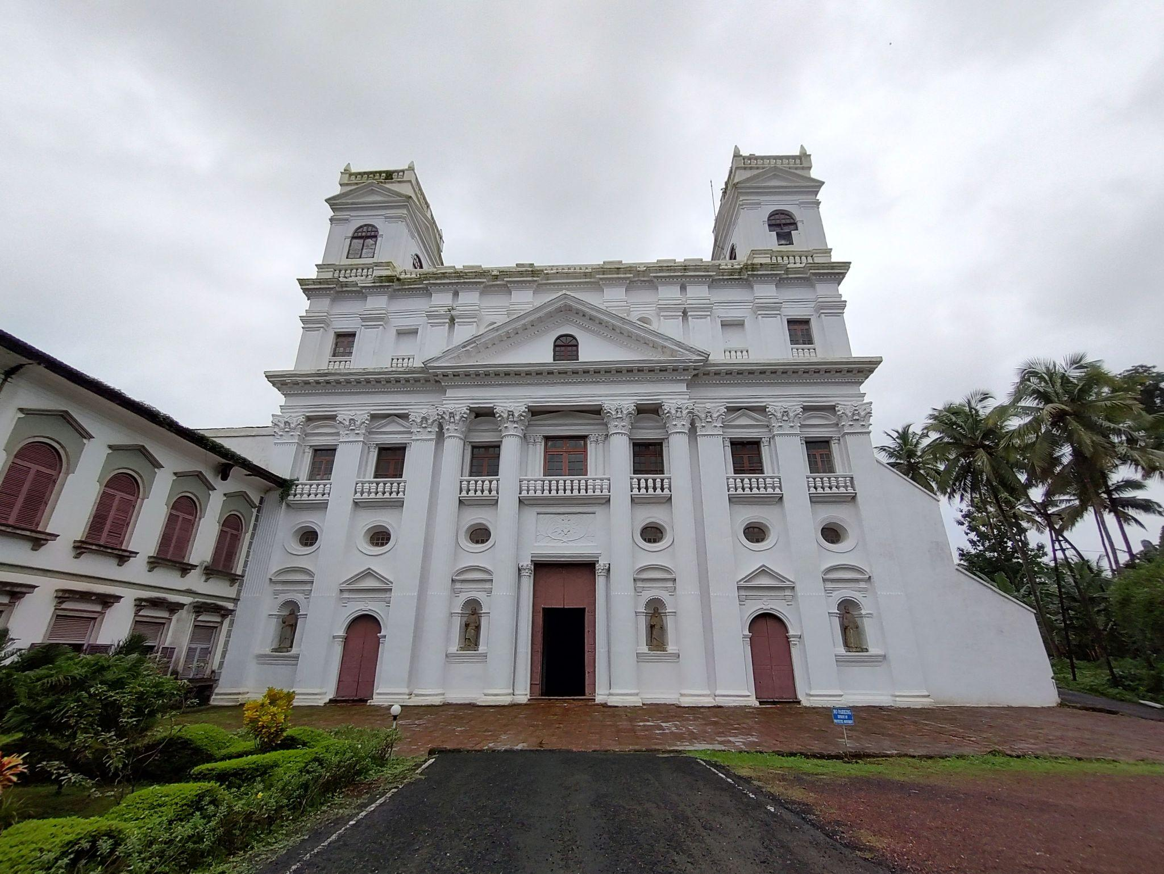
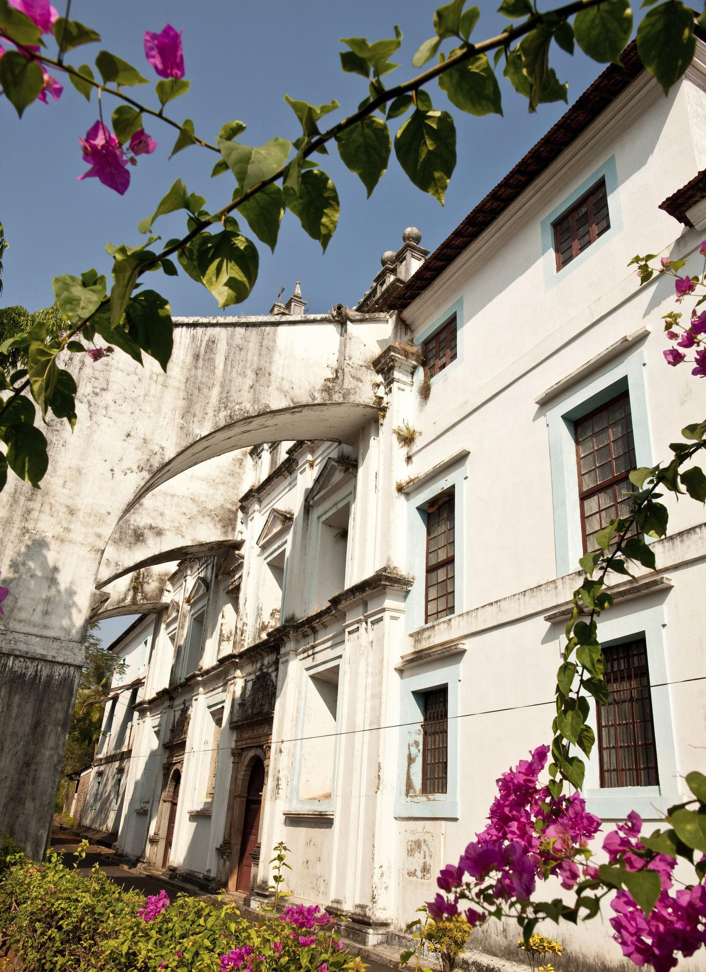
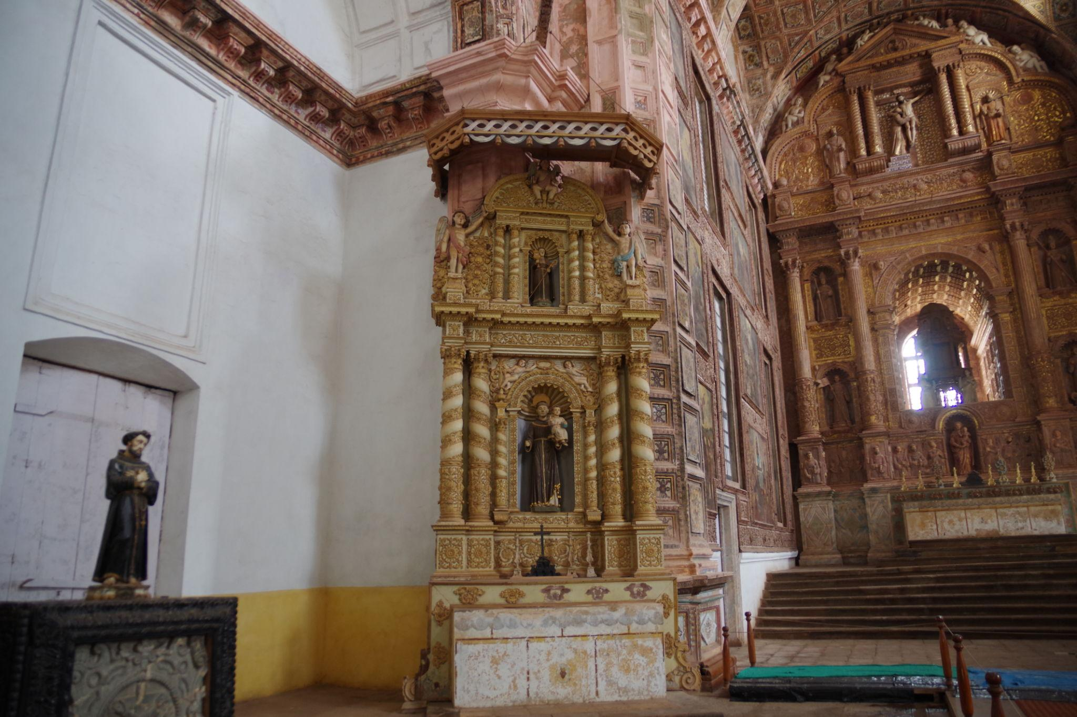
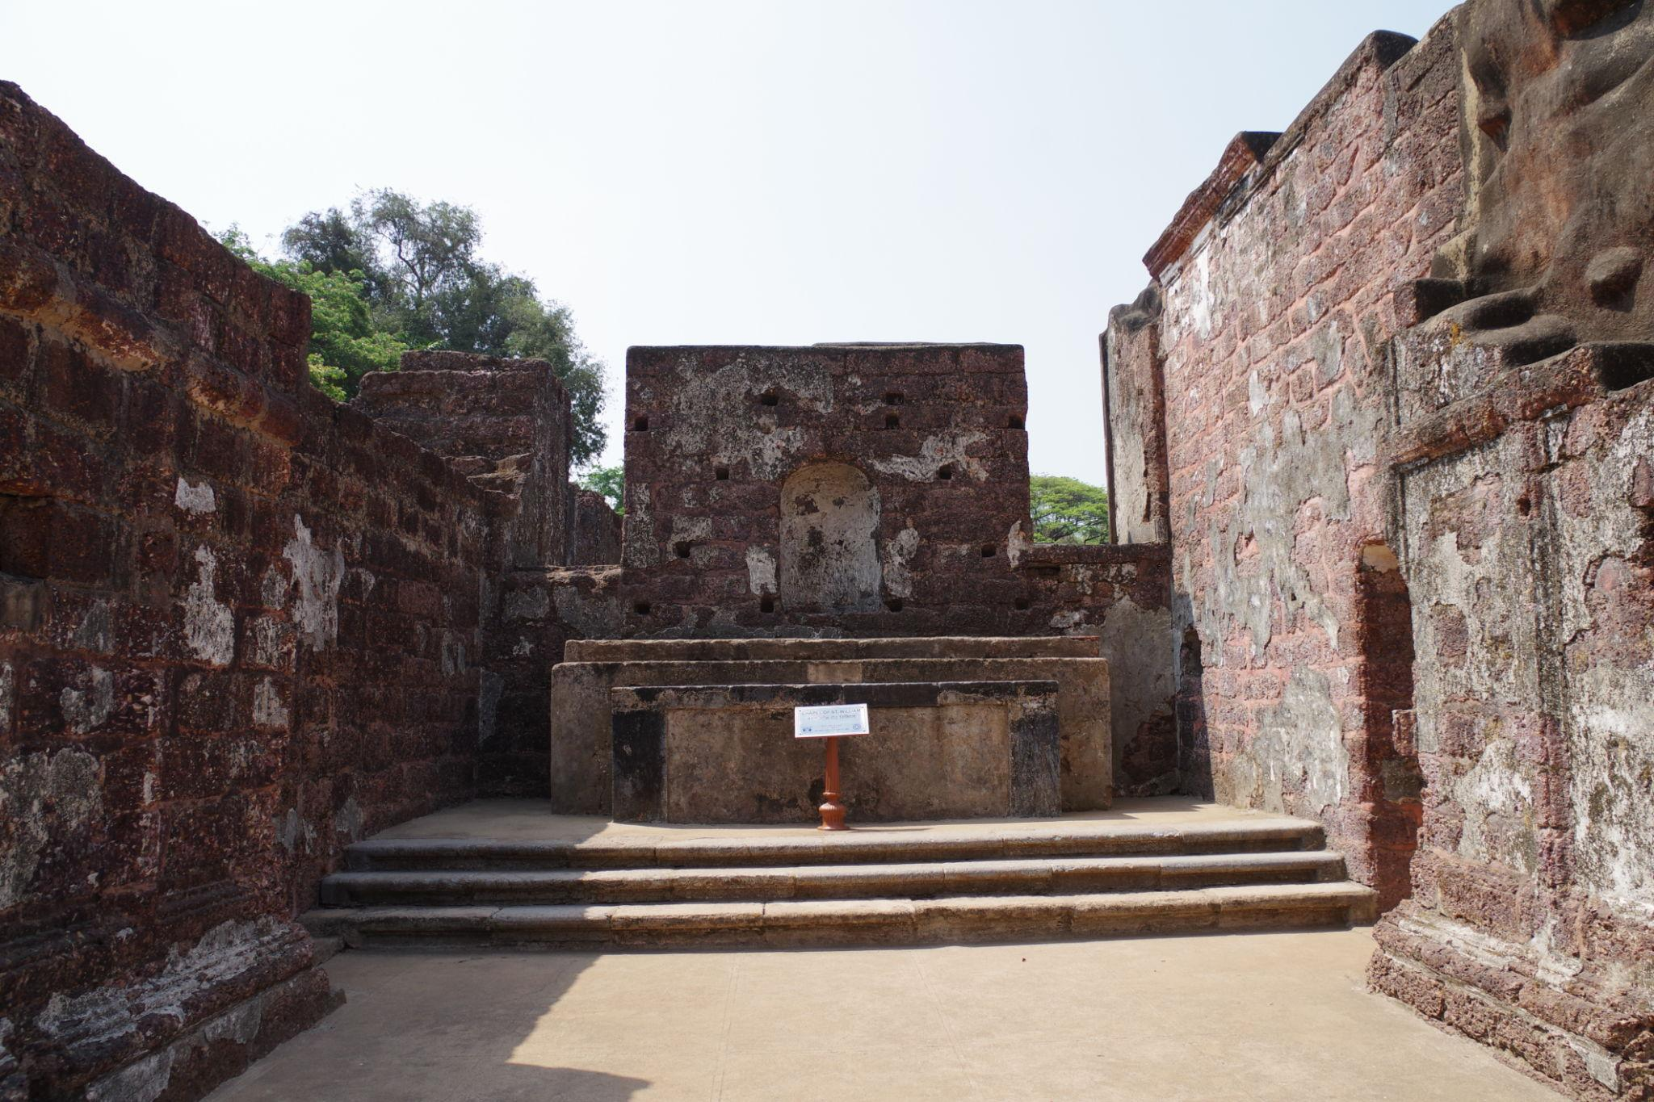

4. Fort Aguada
A historic Portuguese fort offering stunning Arabian Sea views.
Best for:
- Sunset photography
- Historical exploration
- Scenic coastal views
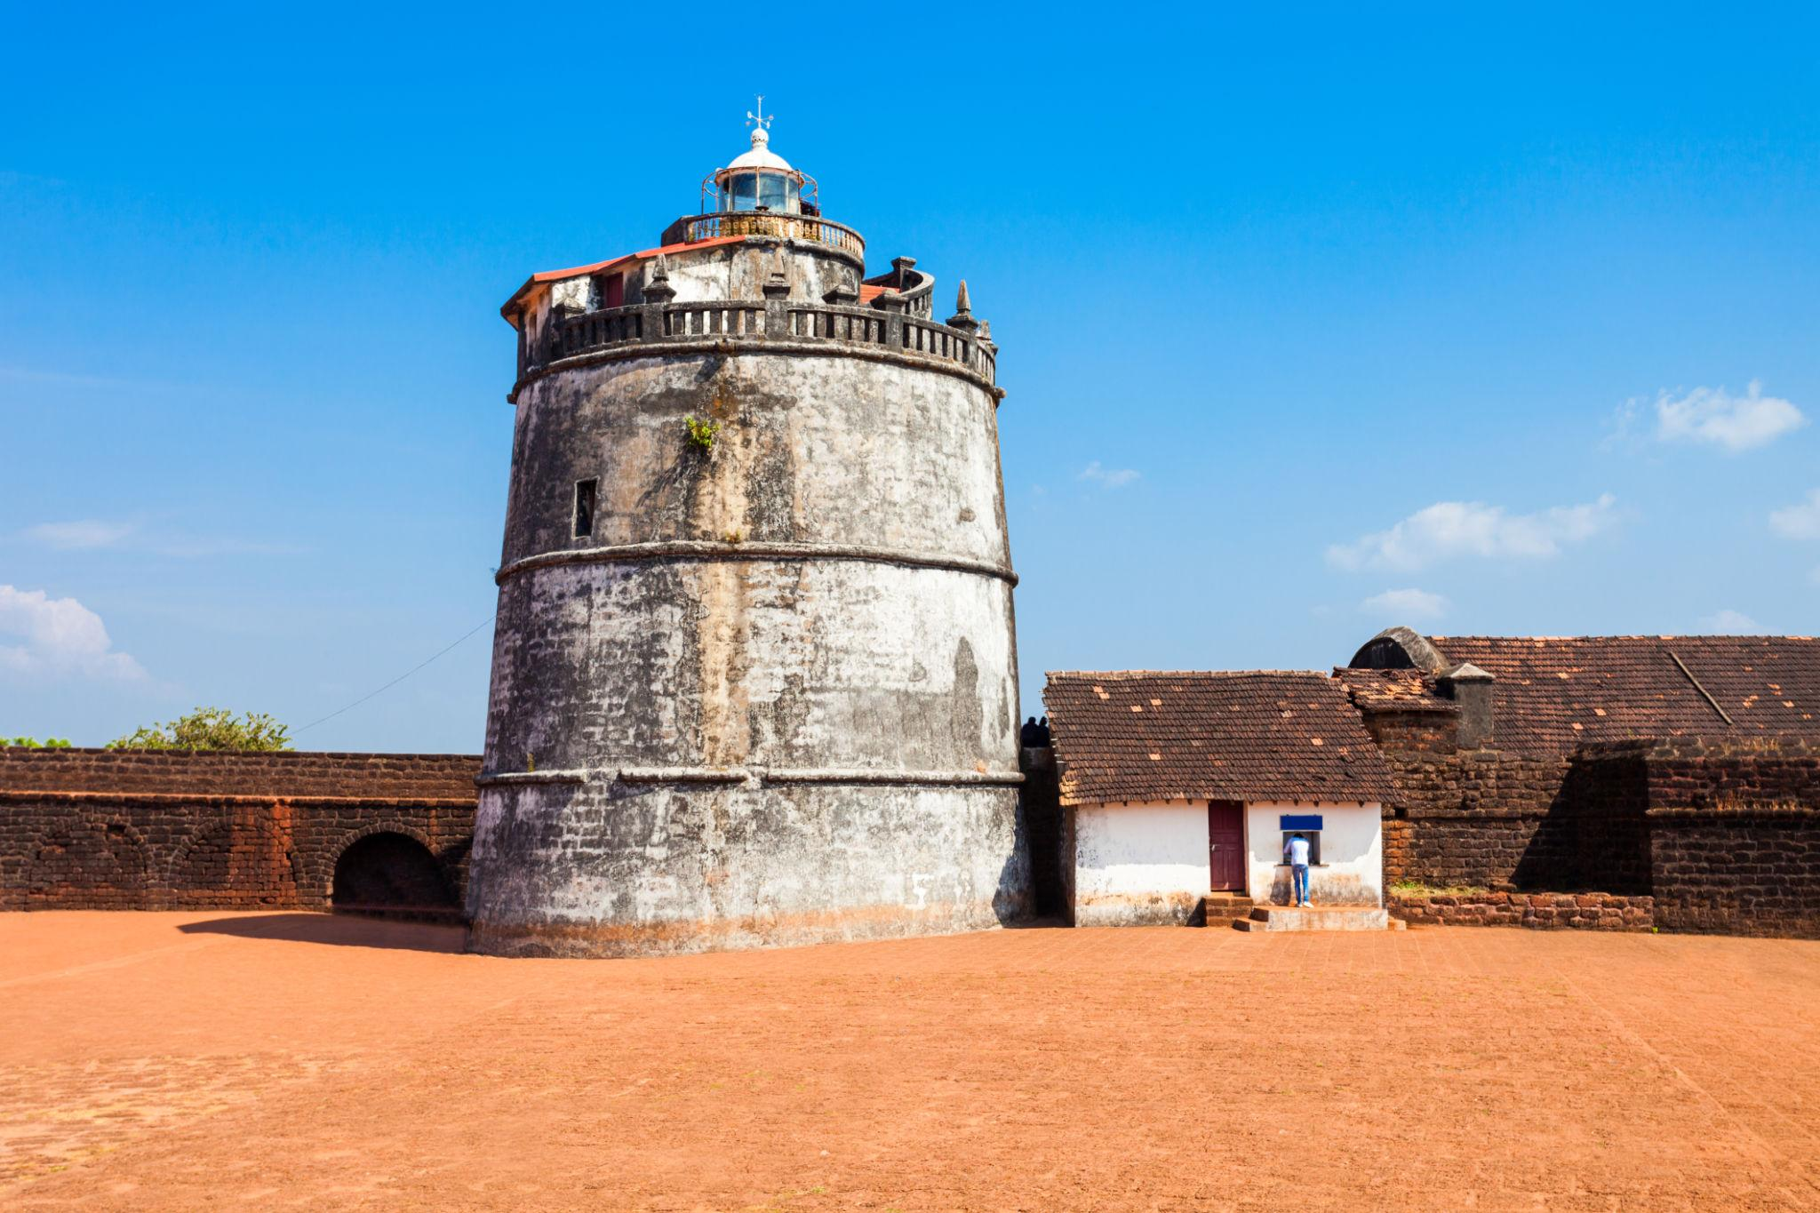
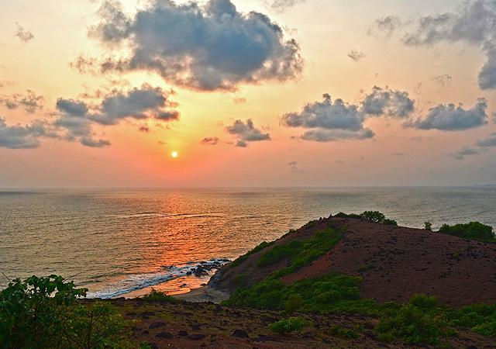
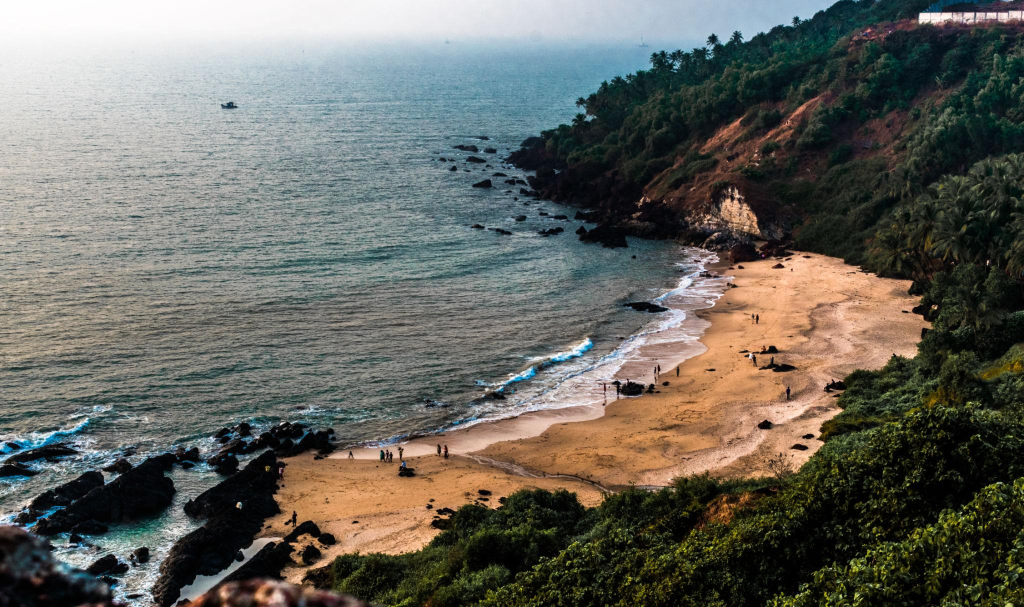
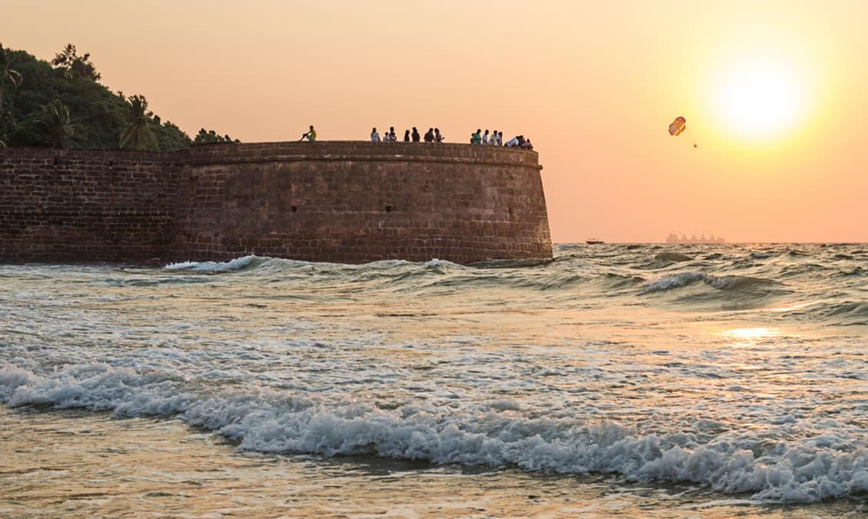
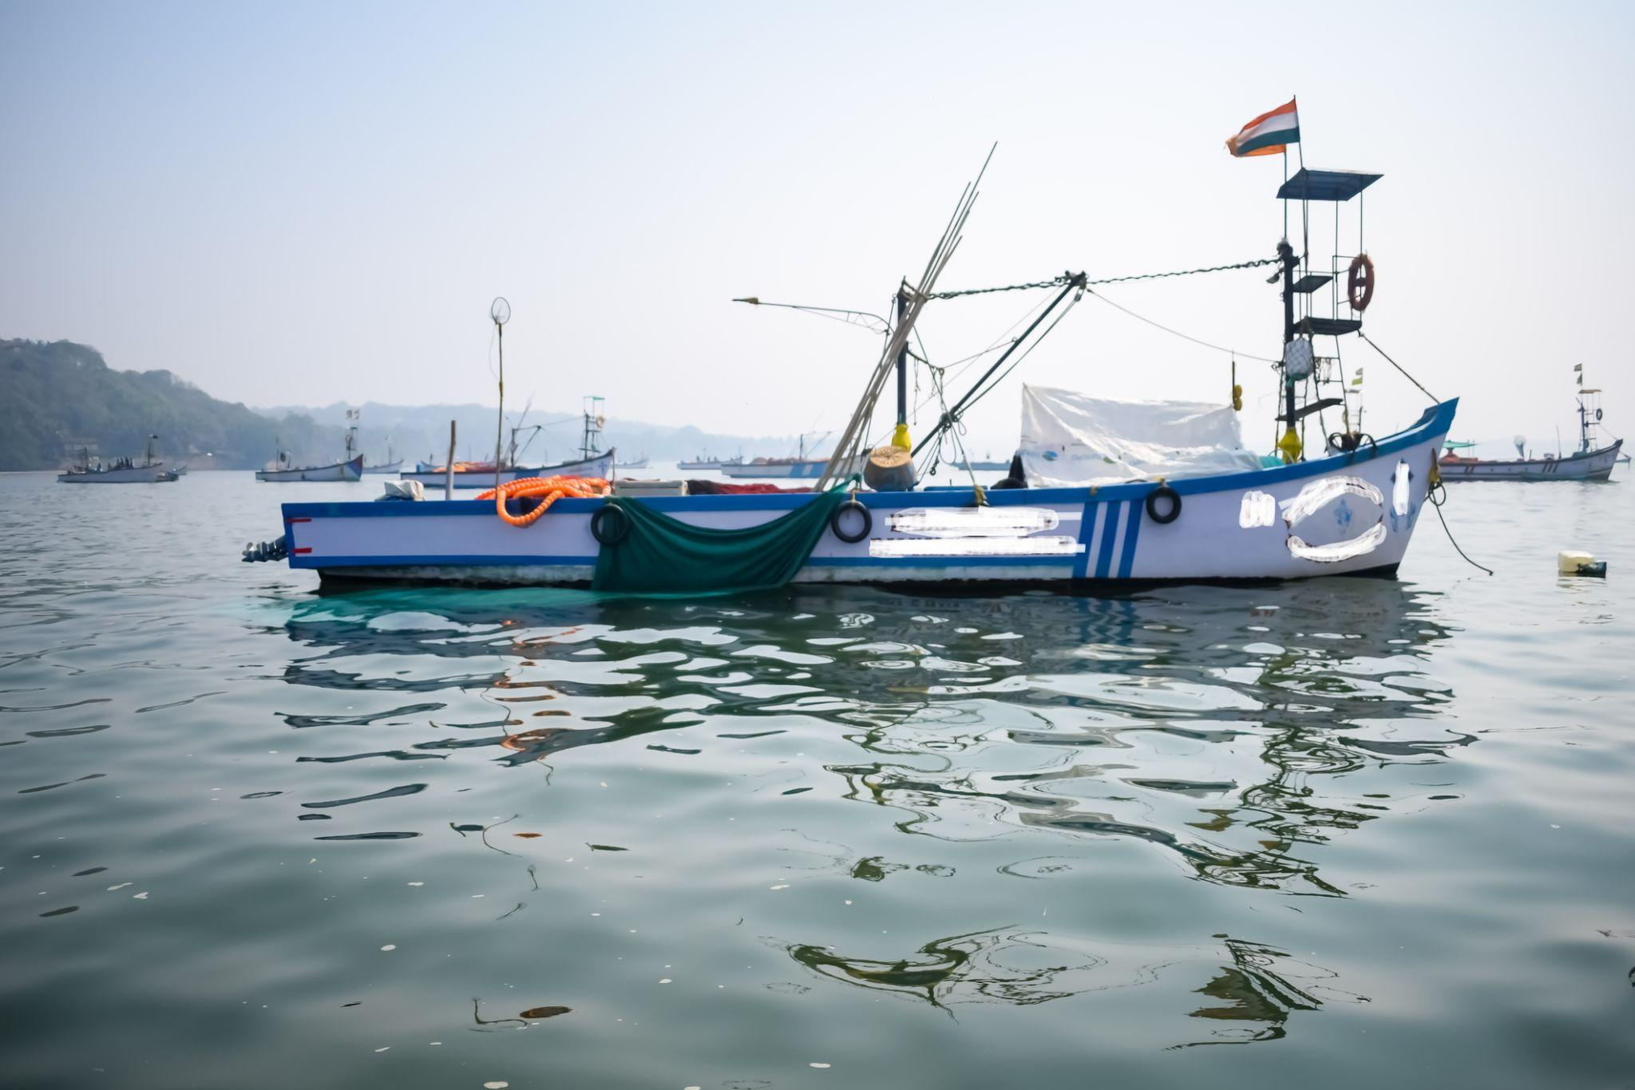
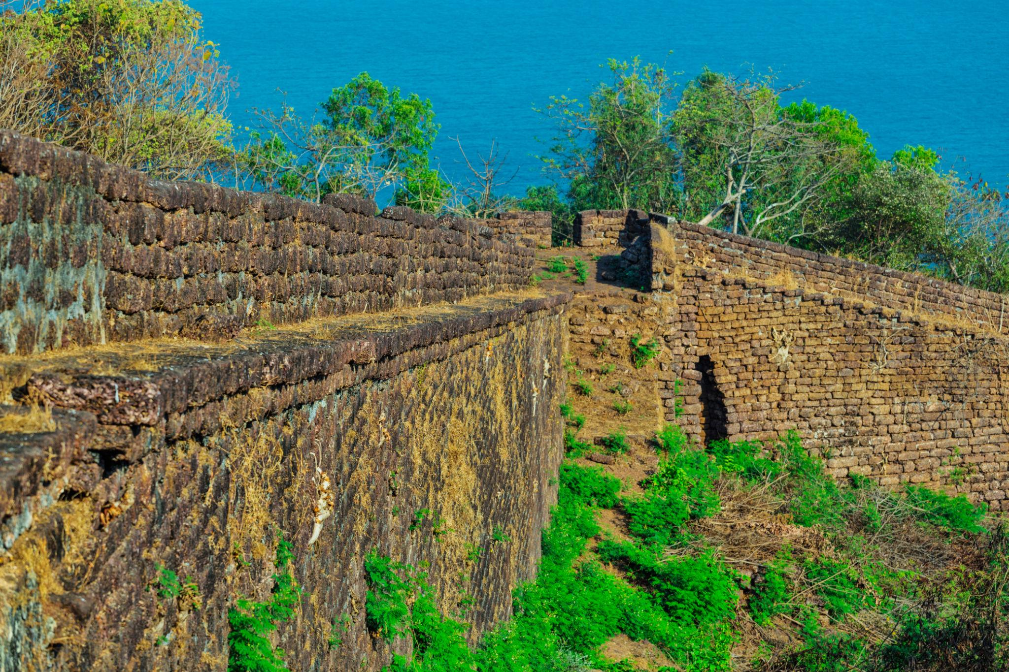

5. Dudhsagar Falls
One of India’s tallest waterfalls surrounded by lush forests.
Activities:
- Jeep safari
- Nature photography
- Trekking adventures
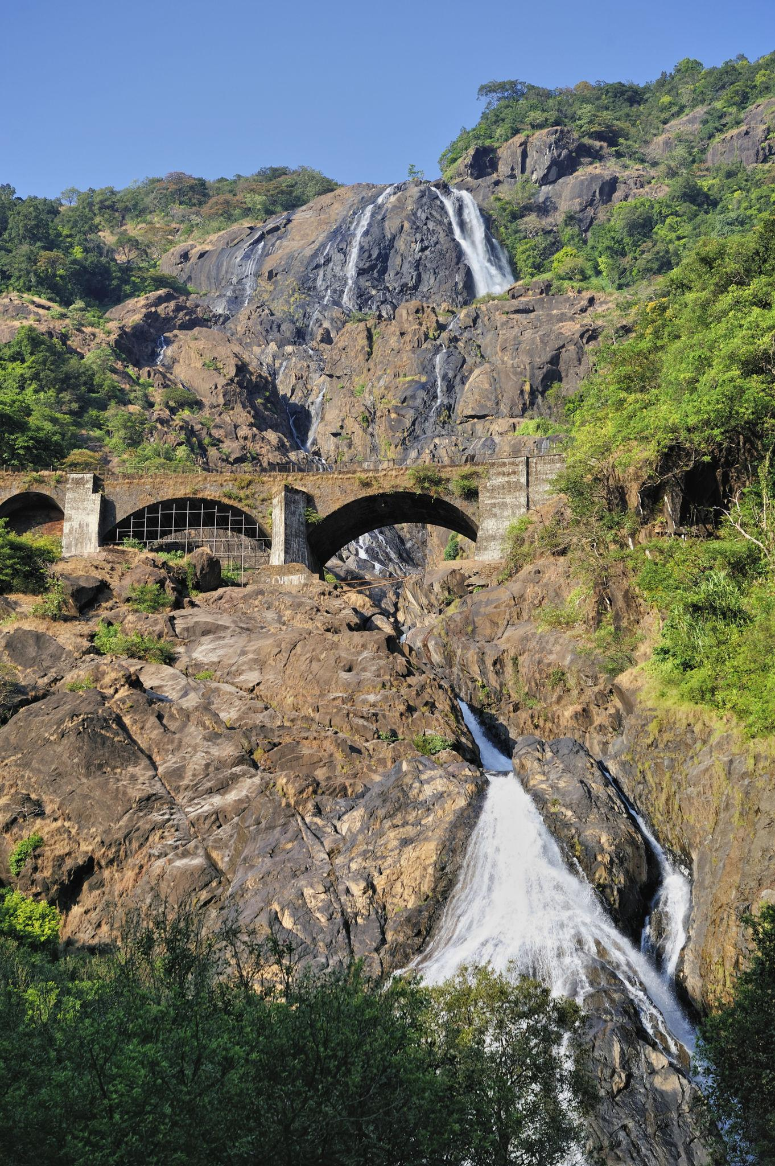
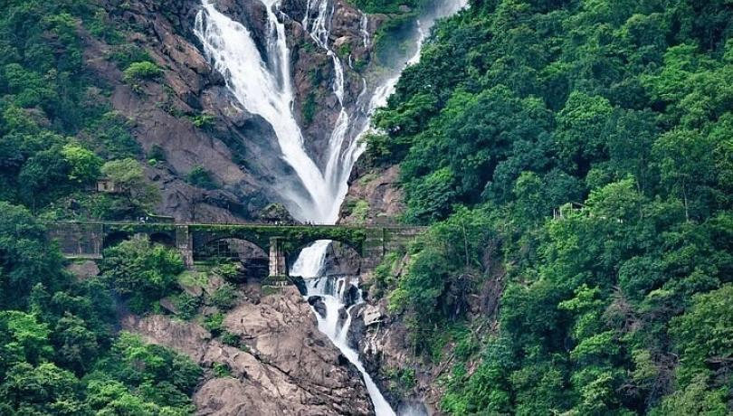
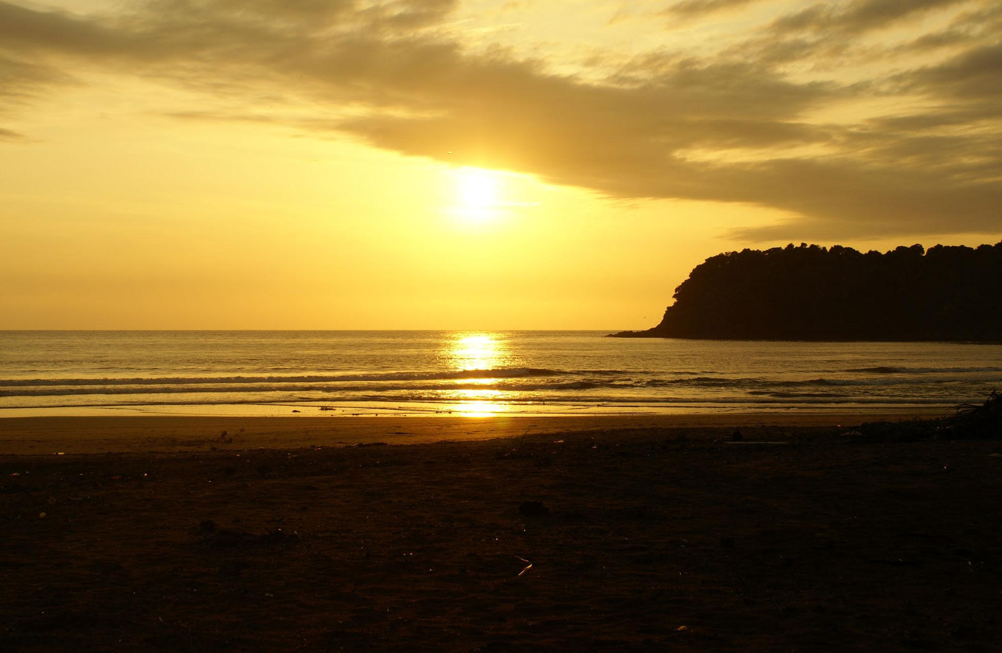
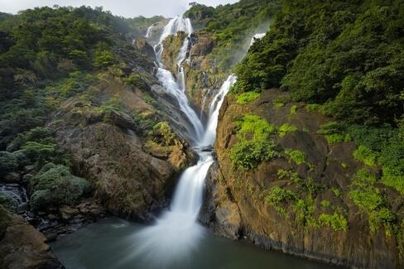
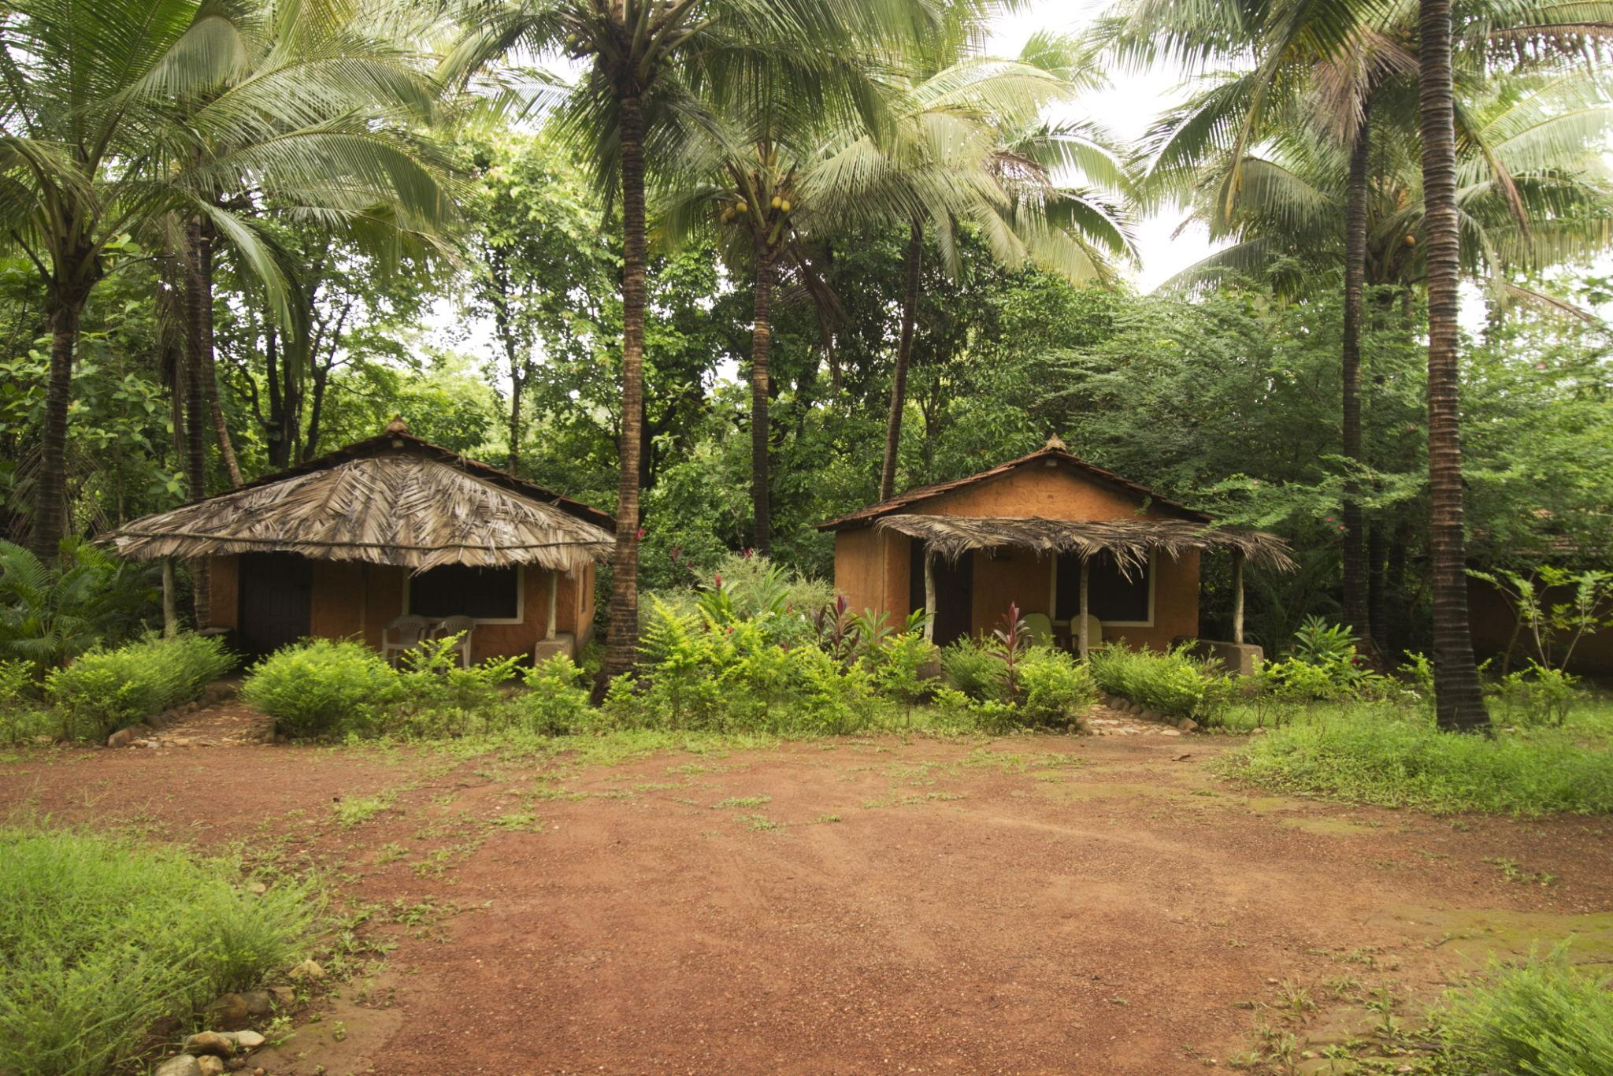
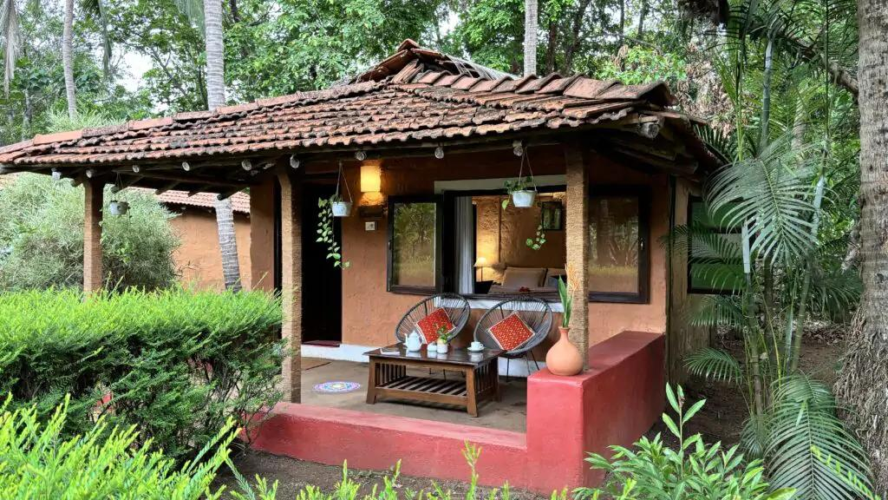
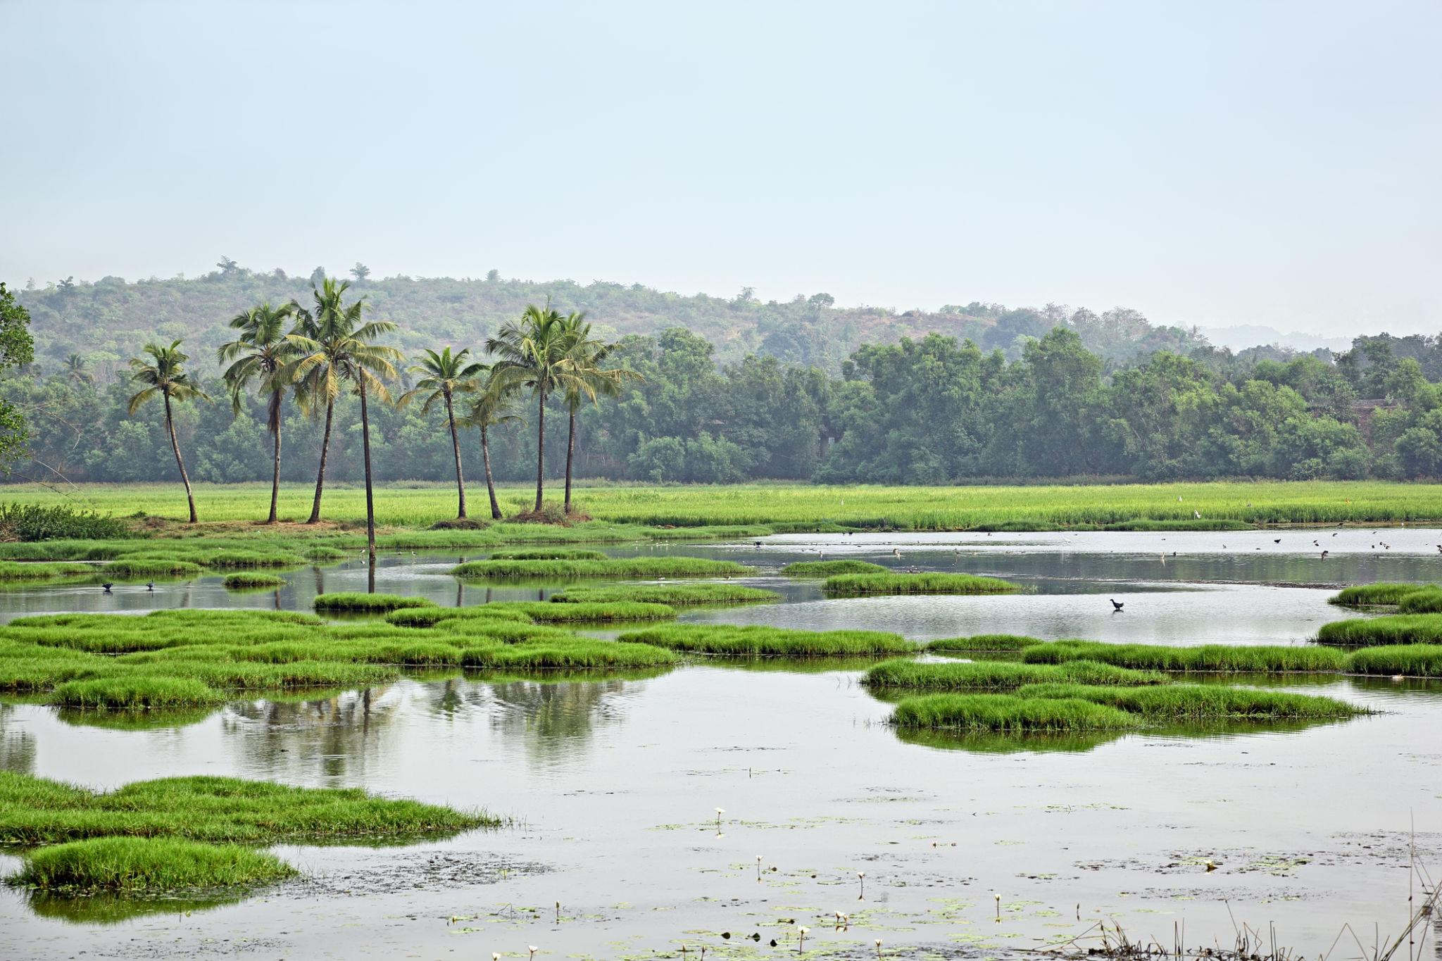

6. Cruise on Mandovi River
A popular evening activity featuring music, dance, and river views.
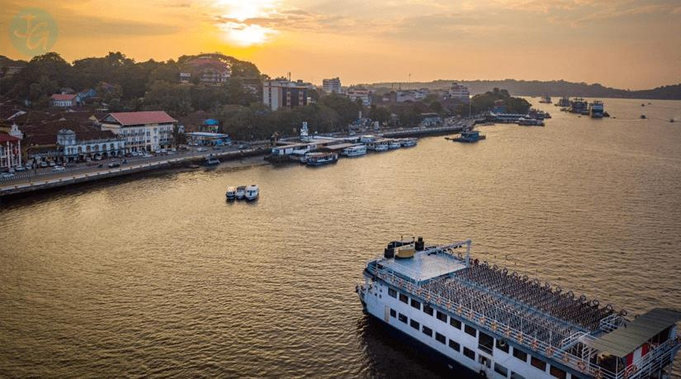
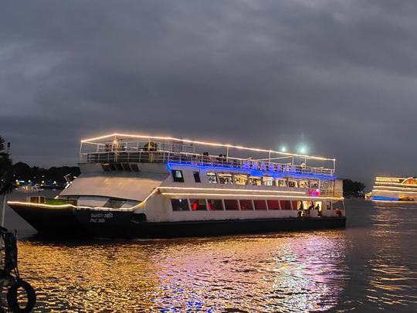
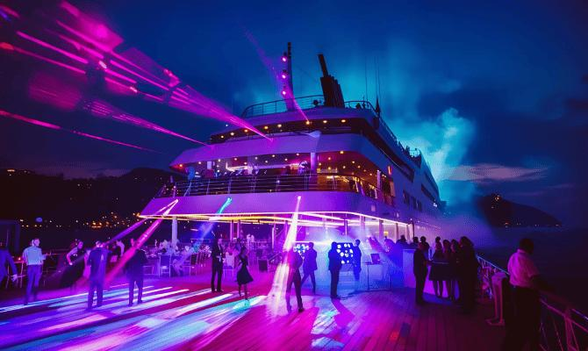
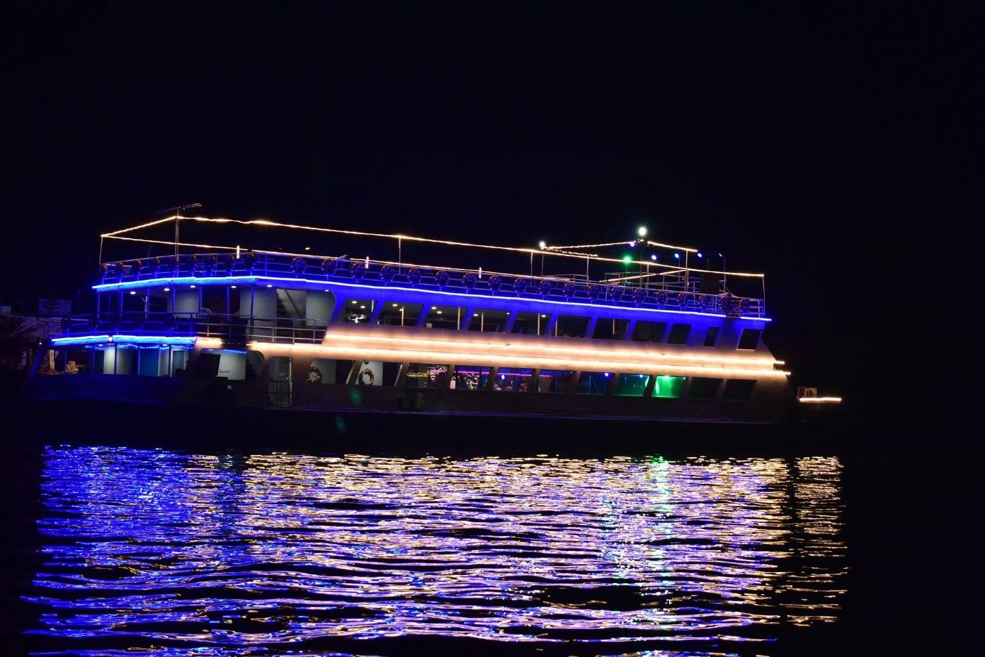
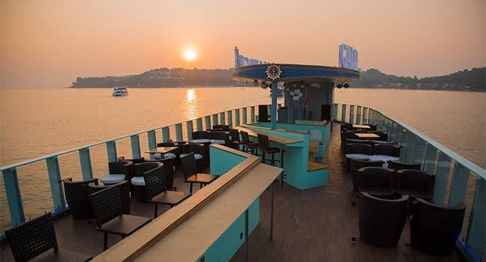
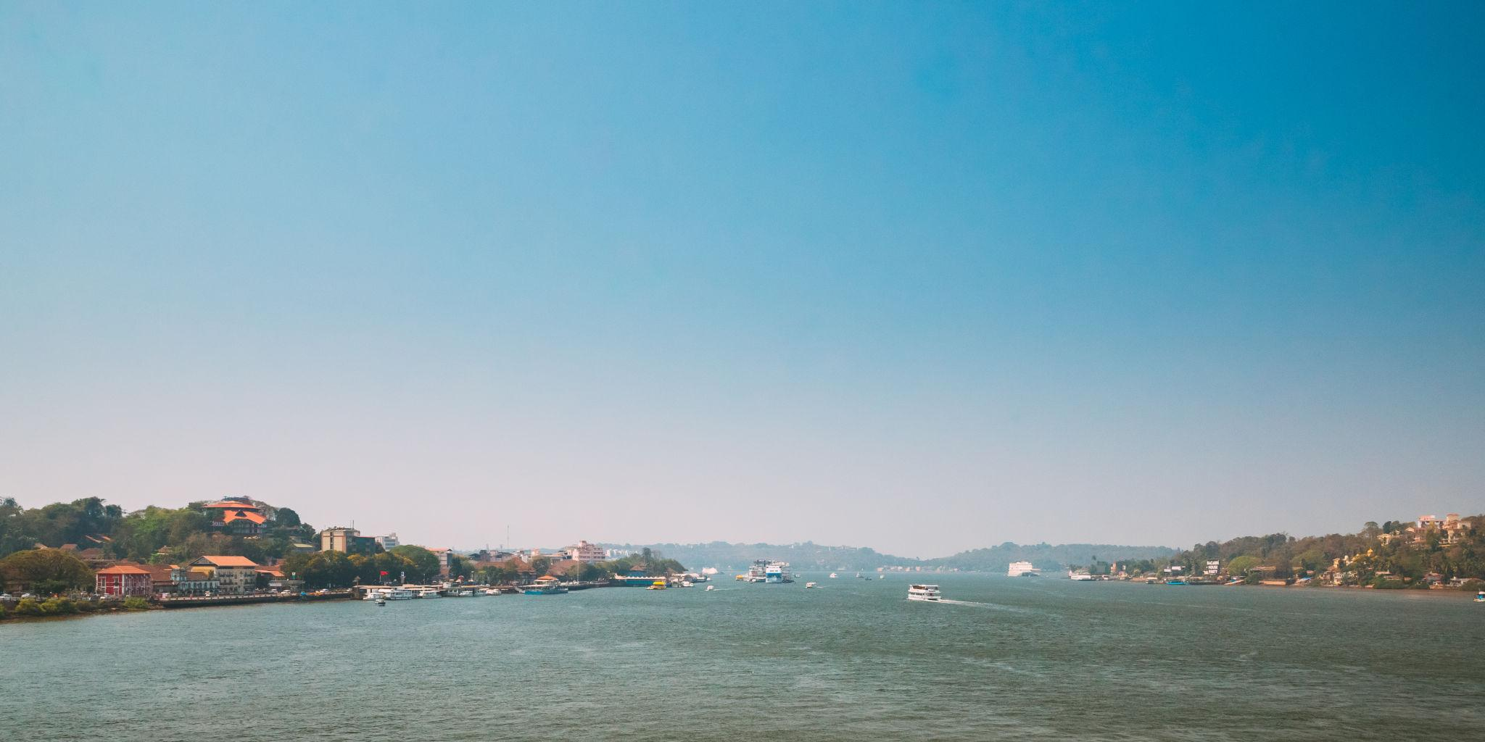
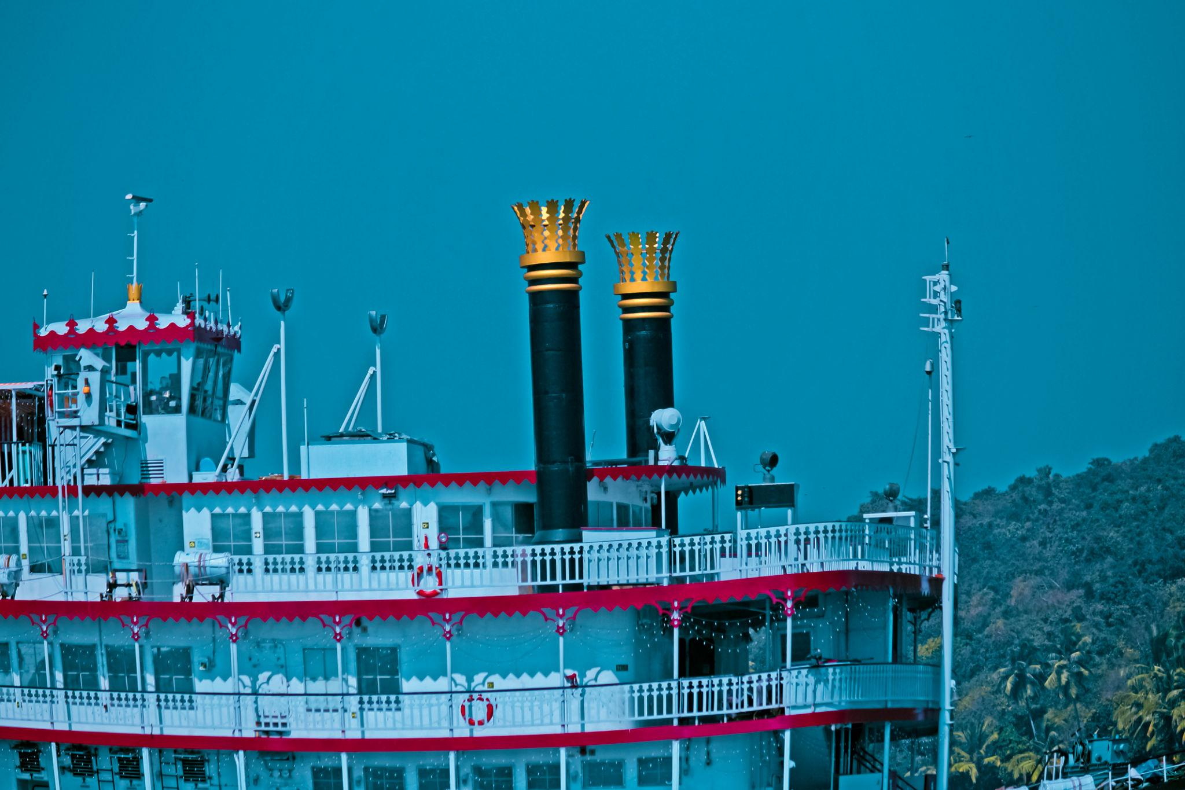
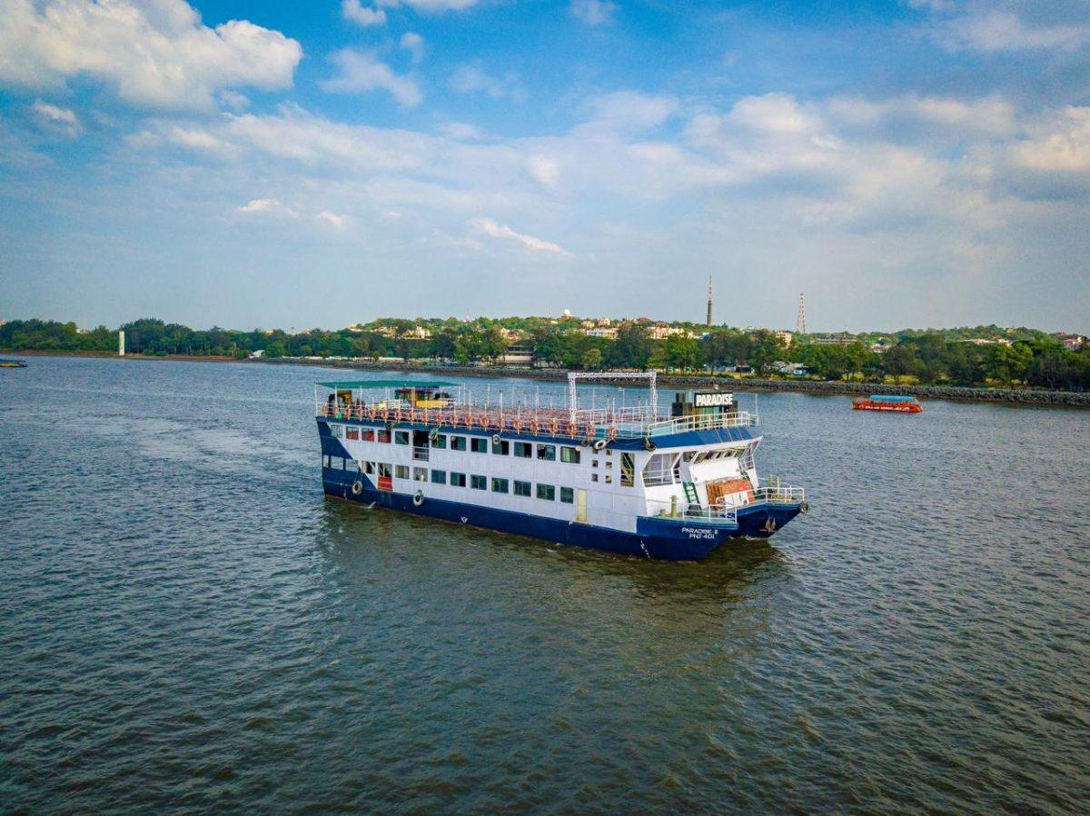

Best Things to Do in Goa
- Relax on beautiful beaches
- Enjoy water sports & scuba diving
- Experience Goa nightlife & beach clubs
- Visit churches & Portuguese heritage sites
- Take sunset cruises
- Explore flea markets
- Try beachside cafés & seafood
- Enjoy yoga & wellness retreats
- Rent bikes & explore coastal roads

Best Time to Visit Goa
Season | Months | Weather
Peak Season | November – February | Pleasant & best for beach activities
Summer | March – May | Hot but less crowded
Monsoon | June – September | Green landscapes & waterfalls
The best time to visit Goa is during winter.

How to Reach Goa
By Air
Main airports:
- Dabolim Airport
- Manohar International Airport
Direct flights available from major Indian cities.
By Train
Goa is connected through:
- Madgaon Railway Station
- Thivim Railway Station
By Road
Well-connected highways from:
- Mumbai
- Bangalore
- Pune

Famous Foods to Try in Goa 🍤
- Goan Fish Curry
- Prawn Balchão
- Bebinca
- Vindaloo
- Cafreal
- Feni
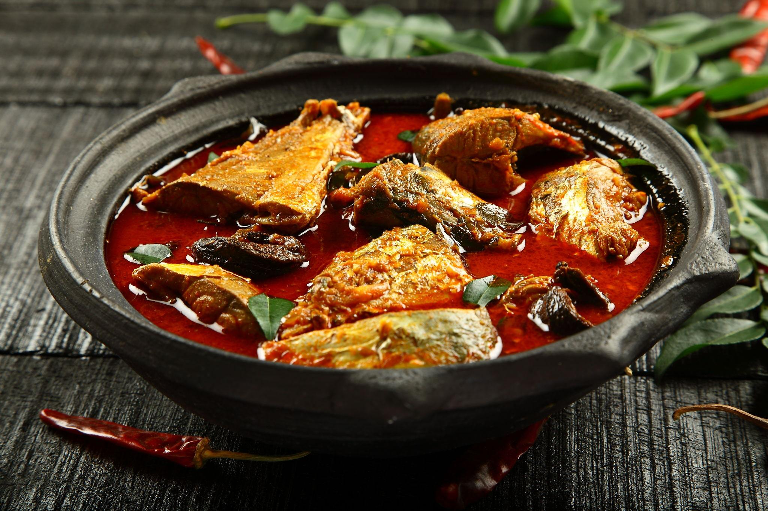
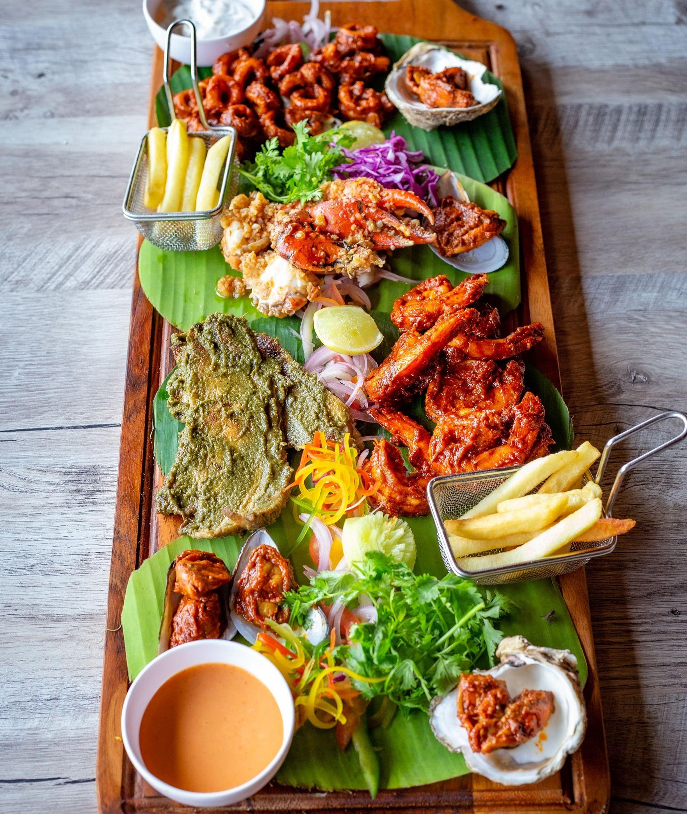
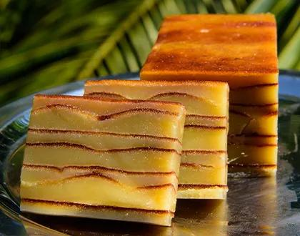
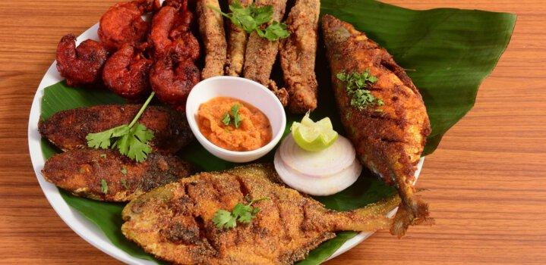
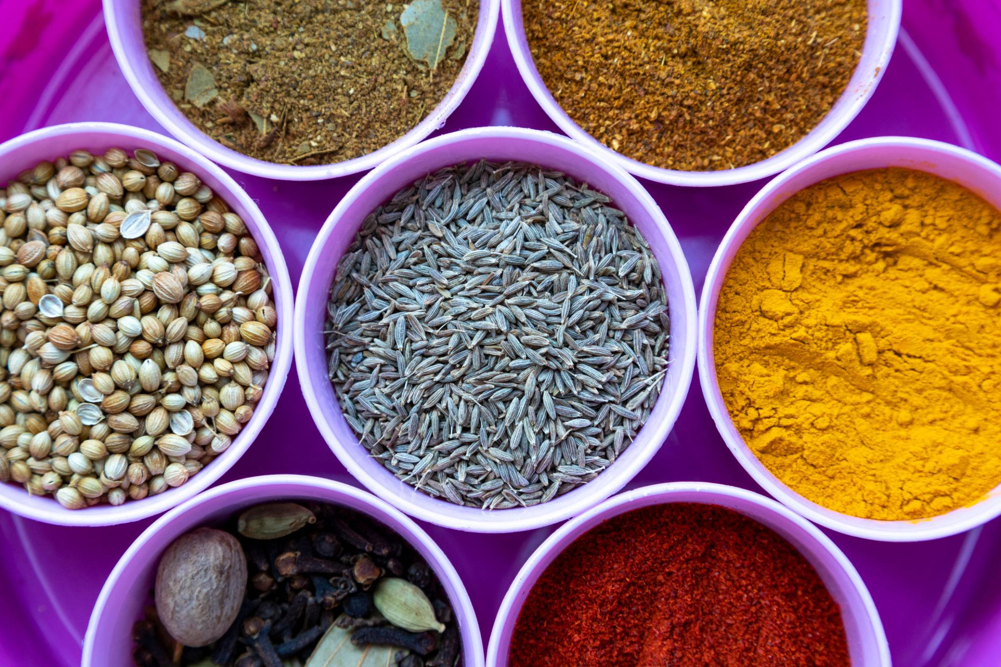
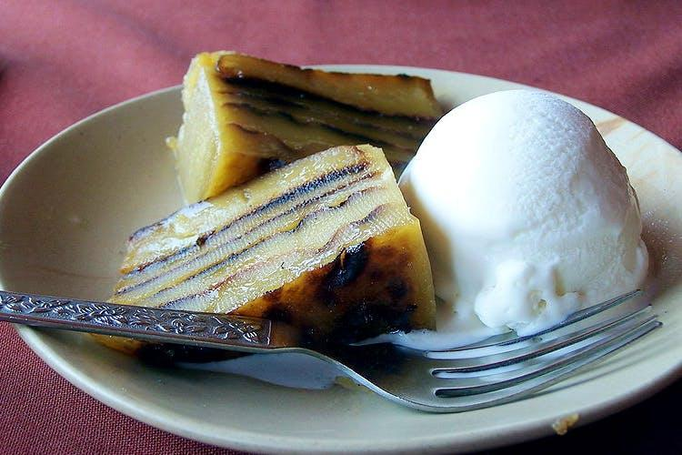

Luxury Experiences in Goa ✨
- Beachfront luxury resorts
- Private yacht parties
- Luxury spa retreats
- Romantic candlelight beach dinners
- Private villa stays
- Sunset catamaran cruises
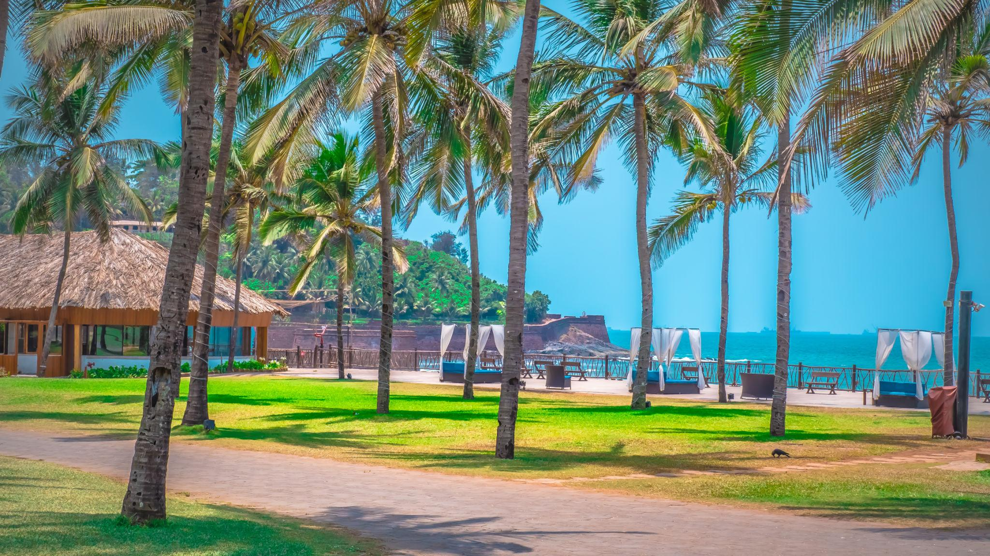
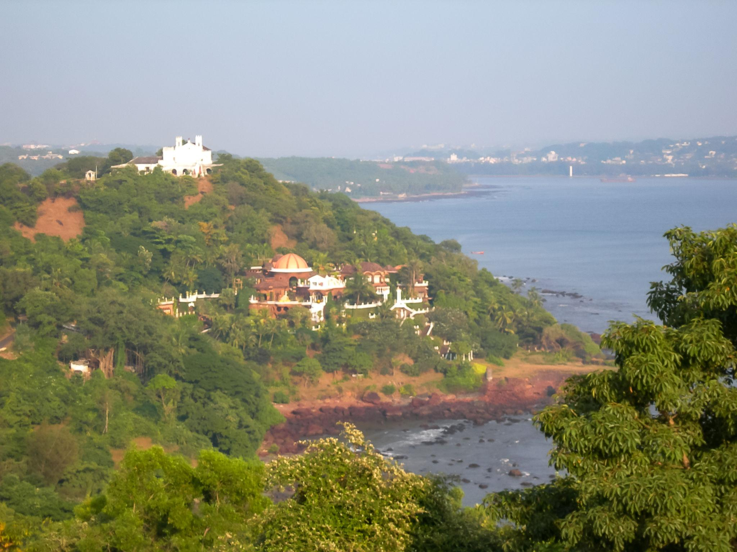
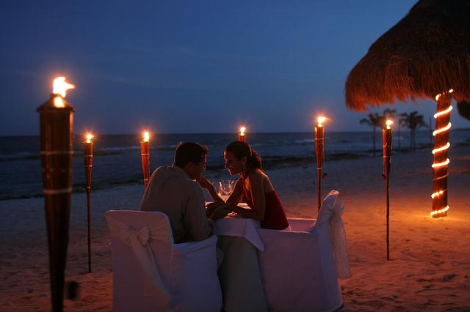
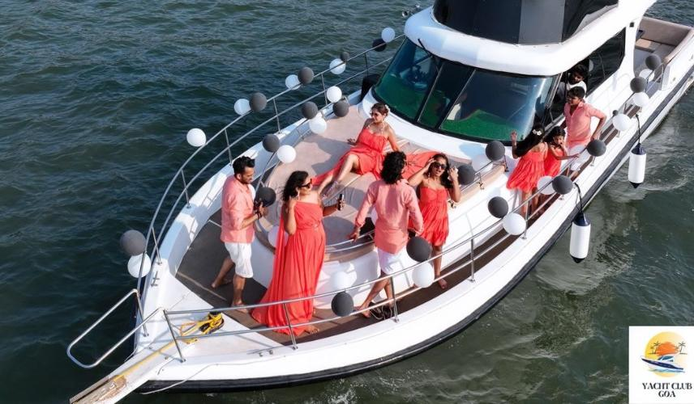

Goa Travel Tips
- Carry beachwear & sunscreen
- Rent scooters for easy travel
- Stay hydrated during summer
- Respect local culture & beaches
- Book hotels early during peak season
- Avoid swimming during rough monsoon seas

Why Choose INTRO TRAVELS INDIA for Goa?
With INTRO TRAVELS INDIA, you get:
- Customized Goa holiday packages
- Honeymoon & family tours
- Budget & luxury resort options
- Water sports bookings
- Airport transfers
- Guided sightseeing tours
- Beach party & cruise arrangements
- Group departures & private tours
Goa is a destination where tropical beaches, exciting nightlife, Portuguese heritage, luxury resorts, and unforgettable adventures come together to create the perfect beach holiday experience.

